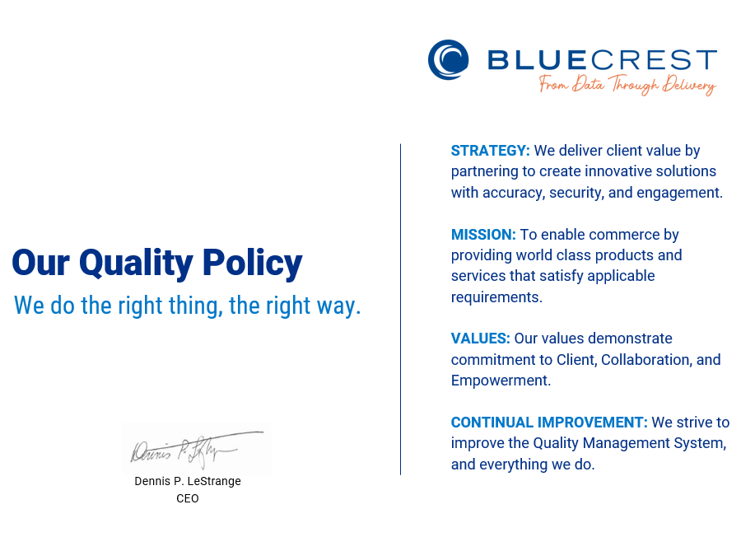 History:
Revision | Change Description | Approved By | Date
1 | Initial Creation of Document.  Previously included in Quality Manual MSM001B Revision 2 | Steve Varga | 15-May-2021
2 | Updated Values: from “Our behaviors” to “Our values” and Continual Improvement: from “Of the Quality Management..” to We strive to improve the Quality Management…” | Steve Varga | 08-Aug-2023

